With capacitor:

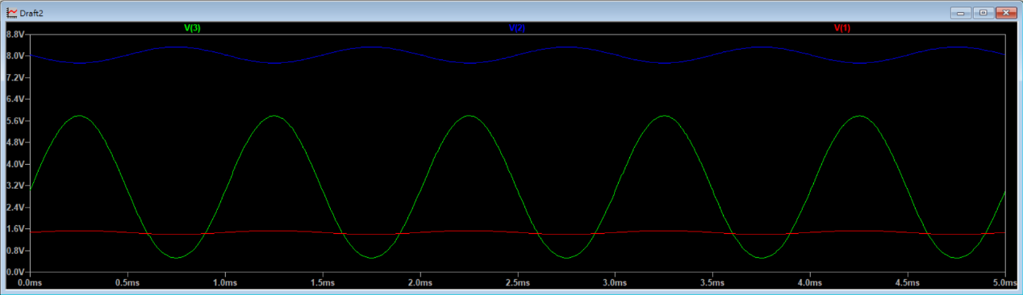

|  |  |  |  |
| --- | --- | --- | --- |
| Simulation | V1 | V2 | V3 |
| Vpp(V) | 0.139896 | 0.592101 | 5.2654 |

Av1=4.2324

Av2=8.8927

Av3=37.638=Av1*Av2

|  |  |  |  |
| --- | --- | --- | --- |
| Measurement | V1 | V2 | V3 |
| Vpp(V) | 0.11 | 0.4 | 3.92 |

Av1=3.64

Av2=9.8

Av3=35.64=Av1*Av2

Before adjust:

|  |  |  |
| --- | --- | --- |
|  | V3(V):without capacitor | V3(V):with capacitor |
| Simulation | 0.563931 | 5.2654 |
| Measurement | 0.56 | 3.92 |

* V3 become smaller

|  |  |  |  |
| --- | --- | --- | --- |
| Simulation | V1 | V2 | V3 |
| Vpp(V) | 1.19938 | 5.34832 | 4.79324 |

Av1=4.46

Av2=0.896

Av3=3.996=Av1*Av2

|  |  |  |  |
| --- | --- | --- | --- |
| Measurement | V1 | V2 | V3 |
| Vpp(V) | 1.12 | 4.96 | 4.4 |

Av1=4.43

Av2=0.887

Av3=3.929=Av1*Av2

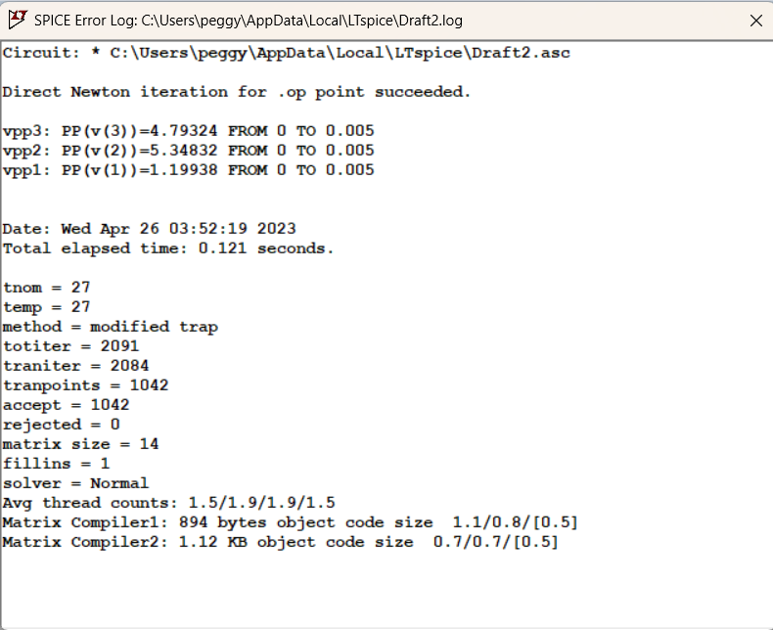

V2 and V1 in step9 are significantly larger the V2 and V1 in step5